class Solution:

def isPowerOfTwo(self, n: int) -> bool:

for i in range(32):

if n == math.pow(2, i):

return True

else:

pass

return False

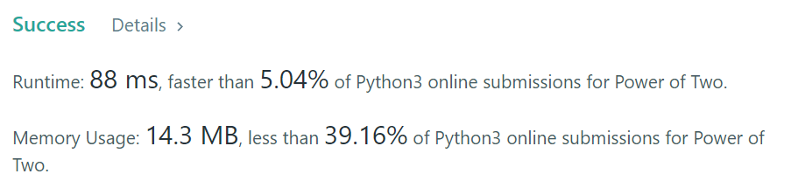

class Solution(object):

def isPowerOfTwo(self, n):

"""

:type n: int

:rtype: bool

"""

return n > 0 and not (n & n-1)